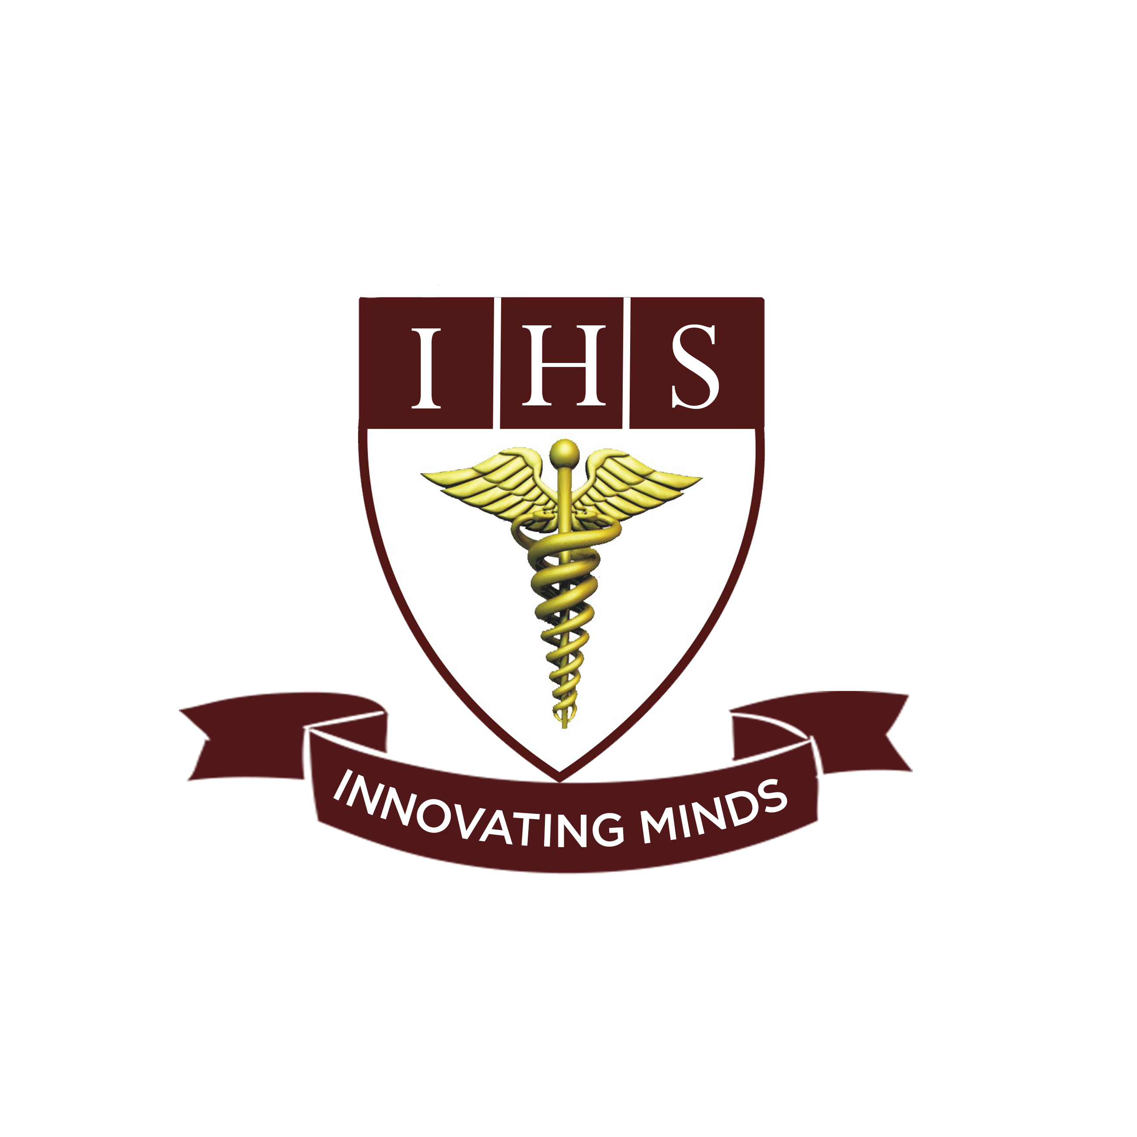
Institute Of Health Sciences
Peshawar
CAREER OPPORTUNITIES
Position | Qualification | No of Post | Experience | Gender
Principle/AP  (Nursing) | MSN,BSN | 1 | 2-5 Years  (Teaching Experience) | Male/Female
Lecturer  (Nursing) | BSN | 4 | 2 year  (Teaching Experience) | Male/Female
Principle/AP  (Anesthesia) | MPH,BS-Anesth | 1 | 2-5 Years  (Teaching Experience) | Male/Female
Lecturer  (Anesthesia) | BS-Anesthesia | 4 | 2-5 Years  (Teaching Experience) | Male/Female
Principle/AP  (Radiology) | MPH,BS-Radiology | 1 | 2-5 Years  (Teaching Experience) | Male/Female
Lecturer  (Radiology) | BS-Radiology | 4 | 2 year  (Teaching Experience) | Male/Female

- Last date to apply is Monday 7th June, 2021.
- Shortlisted Candidates will be called for Demo/Test and interview.
- Mail your resume on hr@ihs.edu.pk or drop at admin office on or before due date.
- IHS is an equal opportunity employer.

Institute of health sciences near Hayatabad toll plaza ring road Peshawar

